**WATER FOUNTAIN / DISPENSER.**

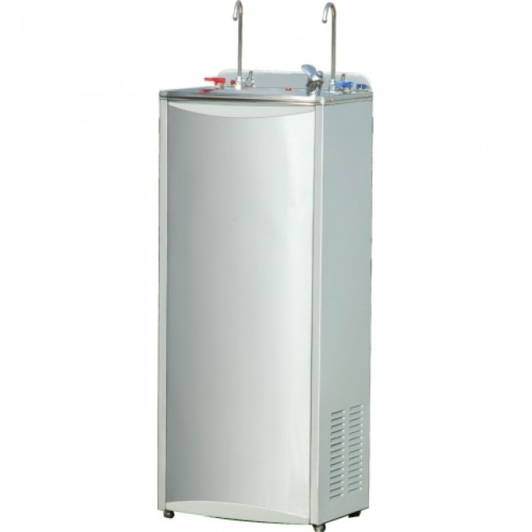 **1. PURE-PRO WF-CH**

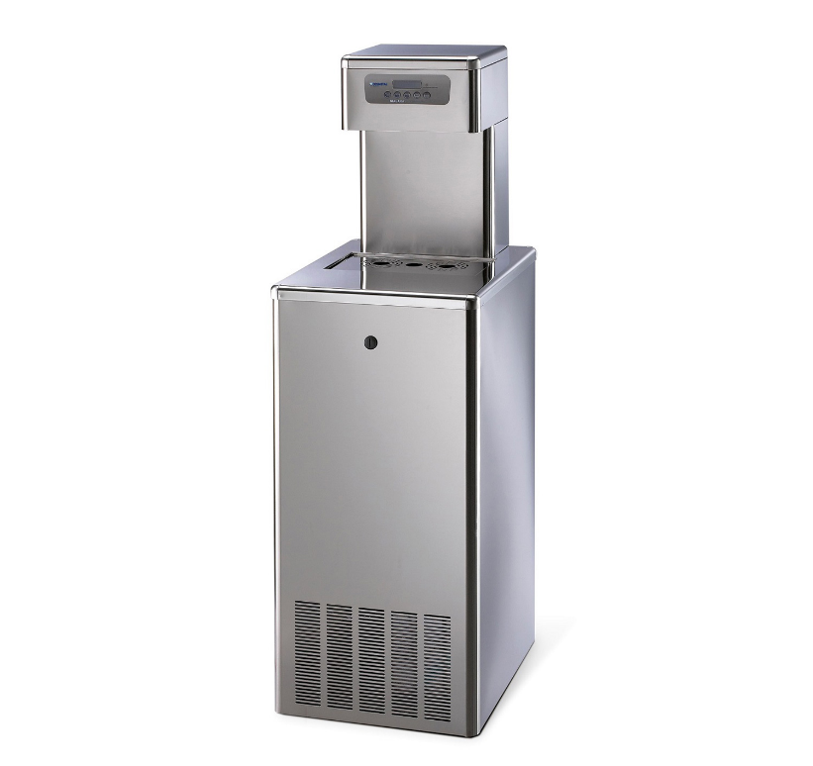 **2. Pure-Pro 120 Stainless Steel SL Cold & Ambient Freestanding Water Cooler 120 Ltr/Hr.**

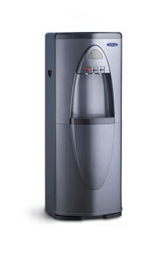 **3.) WATER SYSTEM, PURE-PRO OFFICE BOY CW929P**